**STEPS TO USING DOXIMITY:**

**Step 1:** Download the doximity app  **Step 2:** Press on “dialer”

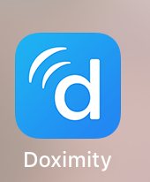 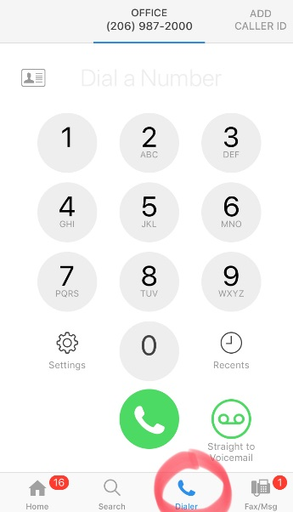

**Step 3:** Select “Add Caller ID”

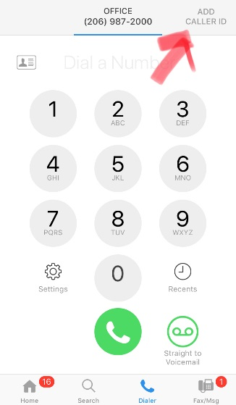

**Step 4:** Add whatever number you’d like (office phone, main operator number, etc.). You can have multiple numbers.

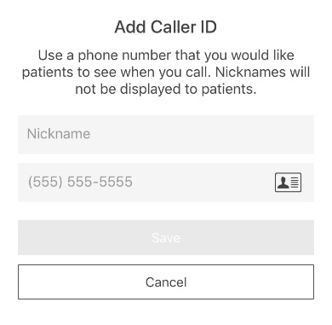

**Step 5:** When you want to make a call, use the dialer in the app. It certainly doesn’t have the other utilities of jabber but has worked well for calling patients/parents when on call.